**IN THE UNITED STATES PATENT AND TRADEMARK OFFICE**

**Provisional Patent Application**

**Title: METHOD FOR PROVIDING INDIVIDUALIZED PATIENT EMERGENCY CARE**

**INVENTOR: Bernard C Ouellette**

**FIELD OF THE INVENTION**

The present invention relates to the transformation of an Emergency Management Team’s (EMT) Standard of Care Protocols, which are a generic set of care standards for various types of injuries applied to any person receiving emergency treatment, and upon which the EMT relies, when providing treatment for an injured person. The invention transforms the Standard of Care Protocol into a novel, Individualized Protocol that is strengthened with information memorialized and recorded in the person’s medical records. The invention minimizes the negative impact of existing health issues that can affect the quality of care being delivered by the EMT.

**BACKGROUND**

With the continuing development of new pharmaceuticals and vaccines, new diagnostics and advanced surgical procedures, there are more issues that can complicate the delivery of health care and clinical procedures. More comprehensive information provided to an EMT in the form of accessible medical records offers the opportunity to reduce the risk of such issues as negative drug interactions and severe allergic reactions such as such as anaphylaxis. For instance, when information in the injured person’s medical records indicates allergic reactions to penicillin, the EMT can substitute for an alternate antibiotic, or when drug reactions to medications for diabetes, hepatitis or aids are known, the EMT can chose a different care agent to treat the injured person without exposure to the cross-reaction risk.

New technological developments such as cell phones and wireless accessibility of information files stored on these devices offer an opportunity to improve the quality of information available to care givers such as EMTs by providing critical bases of information at the press of a button at the location of an injured person. This information can be stored in an application (APP) for accessing by an EMT.

Certain emergency alerting devices have been developed during the preceding decades. These include such devices as:

1. Medical Alert System for Home Emergency
2. Guardian Alert 911 Phone
3. LogicMark Freedom Alert Emergency System
4. Ripple 24/7 Personal Safety Monitoring

However, these systems suffer many drawbacks, including:

* range limitation of 600-1300 feet from a base module.

* monthly service charges ranging from $19.95 to $59.95, placing the service beyond the reach many elderly people who are on fixed or limited incomes.

* lack of medical records information that can lead to more precise care services.

* lack of information needed by an EMT to transform a Standard of Care Protocol into an individualize Care Protocol tailored to accommodate the user’s medical history.

Patent Referrences Cited:

1. US7949544B2 Joseph H. Miglietta, J. Barton Ripperger May 24, 2011
2. US8165897B2 Roberto Beraga, Victor Beraga, Ester Beraga, Isidor Beraga, Matilde Beraga January 14, 2014
3. US2011001537A1 John J Janas III, Robert John Thompson, Michael Robert Lustig February 21, 2012
4. US20110046979A1 Paola Karina Marcellus, Lilla Boroczky, Michael C Lee, Victor Paulys Marcellus Vloemans, Ingwer Curt Carsen, Robert Opfer, Charles Langor February 24, 2011

**SUMMARY OF THE INVENTION**

The present invention is an apparatus and a process for quantifying, prepositioning and revealing individualized, encrypted health information that enhances the quality of decision making by an EMT while delivering emergency care to a person injured in a fall due to fainting spells, unsteady gait causing balance issues that can lead to stumbling and falling, physical or skeletal weaknesses that can lead to the inability to stand erect while trying to walk, or who has been involved in an accident (such as a car or machinery accident), an unexpected physical assault or other socially abhorrent event leading to an injury requiring emergency care. More particularly, the present invention provides a person’s information profile relative to medical conditions that can materially affect the type of care needed and provided by an EMT at the site of an unforeseen injury. An SOS alert is sent by the injured person (using technology provided by manufacturers of cell phones) that an injury has been sustained and that immediate emergency care is needed. The SOS is preprogrammed to instantly alert the nearest 911 station of the injured person’s geographic location (using global positioning technology). The 911 station then dispatches an EMT to the location of the injured person. The invention’s objective is accomplished by prepositioning the personal, encrypted information on the user’s device (which is installed on the user’s cell phone as an APP). The EMTlive application retains the encrypted personal data and information for rapid accessing by an attending EMT using the person’s Fingerprint or Facial ID. The information includes: personal identification, an emergency contact, blood type, medications and dosage being taken, inherited diseases, history of allergic reactions that can affect decisions on the choices of care, detailed medical and surgical history, vaccination history and information on any implants the person has had (such as cardiac pacer devices or artificial hips), names of the person’s doctors, health insurance information and the name and information of the person’s preferred hospital in the event hospitalization is deemed necessary by the attending EMT. Another object of the invention is to assist users in the precise awareness of complex nomenclature used to describe medical procedures, diseases treatments and emergency care terminology when making entries to the personal data, encrypted files containing their individualized health information that will be accessed by an EMT. This is accomplished by providing resource links, during the preprogramming process by the user, to databases containing the names of all known diseases, vaccines and preventable diseases identified by the CDC, diseases and disorders including genetic diseases, surgical procedures, implants and prosthetic devices, and links to databases of allergens and allergic reactions from open sources available online or in resource libraries.

**DETAILED DESCRIPTION OF THE INVENTION**

The present invention relates to the delivery of informed care by an Emergency Management Team (EMT) at the geographic location of an injured person needing emergency care. More particularly, the present invention relates to a method of providing encrypted information about a person’s health history, inherited health impediments, and current therapeutic measures prescribed to assist in the maintenance of the person’s health status. By the use of this invention the person being assisted by an EMT can be shielded from the untoward health effects resulting from the provision of unvalidated health care measures that could lead to such episodes as anaphylaxis (in the case of the use of certain drugs that may stimulate an extreme allergic reaction when ingested or injected into hypersensitive persons), severe side effects from cross-reactions to drugs designed to treat certain diseases that are accompanied by complications resulting from conditions such as diabetes, hepatis or AIDS, or heart rhythm disturbances (in the case of a person with a heart pacer or other invasive device), or bone fractures (in the case of patients with hip replacement devices or implanted bone support pins or plates). The invention is designed to have the user define and prerecord relevant information such as blood type, history of allergic reactions, genetic disorders, inherited diseases, surgical and medical histories, vaccinations received, implants information and personal disease information in files stored in the invention for access by an EMT prior to making decisions on appropriate care at the injured person’s location when providing timely care may be critical to the injured person’s prognosis and future wellbeing.

As used herein, the term injury is defined as a medical condition that can be the result at any time of unanticipated fainting spells, unsteady gait causing balance issues that can lead to stumbling and falling, physical or skeletal weaknesses that can lead to an incapacity to stand erect while trying to walk without the aid of a support device such as a cane or a walker or who has been involved in an accident (such as a car or machinery accident), an unexpected physical assault or other socially abhorrent event leading to an injury requiring emergency care. The invention based on wireless cell phone service, eliminates the geographic limitations of central station-based devices which are generally not set up to provide protective services while the user is away from home. The invention facilitates access to prerecorded information that is relevant to the delivery of informed care while reducing the risks that can occur in the event the care being provided by the EMT does not foresee the consequences of health conflicts resulting from the health idiosyncrasies of the person receiving the care. There are other services available to handicapped persons needing such care from companies including Medical Guardian, Mobil Health, Life Station and Alert1. However, such services have geographic alert limitations that prevent their usefulness beyond the reaches of a central station module usually installed inside a person’s home. In most cases such equipment can provide alerts within distances 600 to 1,300 feet from the central module. A critical advantage of the EMTlive invention is that it can provide an alert as far reaching as the range of the cell phone on which it is installed, which can extend to a global reach thereby virtually eliminating critical information delivery impediments, while providing as an emergency care advantage for an injured person requiring aid from an EMT following an injury. An additional advantage of this invention is that it is available as one-time low cost purchase with no further costs to the user, facilitating its potential use by many more persons who may be at risk, whereas competitive devices using a home-based central module are accompanied by initial central equipment costs and monthly rental charges throughout the time a person uses the service, often placing them out of the range of affordability for many persons with limited financial means who could benefit from such services.

Therefore, a need exists for a device offering service for a one-time charge of less than $10. Additionally, there is a need for a device that provides service beyond the user’s immediate environment, thereby providing service when away from home or when travelling.

**BRIEF DESCRIPTION OF DRAWINGS**

Some embodiments of the present invention are illustrated as an example and are not limited by the figures of the accompanying drawings, in which like references may indicate similar elements and in which:

Fig 1- Figure 1 illustrates a perspective view of the Personal Information and its components flowing through each step in the information process toward Complete, Personalized Prepositioned Encrypted Information Assets; and the user’s clinical information key information components flow toward the Complete, Personalized Prepositioned Encrypted Information Assets.

Exhibit 1 Shows a schematic of the table used to record the user’s blood type,

Exhibit 2 Shows a schematic of the table used to record the user’s doctors’ names,

Exhibit 3 Shows a schematic of the table used to record the user’s contact information,

Exhibit 4 Shows a schematic of the table used to record the name of the user’s Insurance Providers,

Exhibit 5 Shows a schematic of the table used to record the names and dosages of the user’s drug,

Exhibit 6 Shows a schematic of the table used to record the user’s inherited diseases and allergies,

Exhibit 7 Shows a schematic of the table used to record the user’s medical and surgical history,

Exhibit 8 Shows a schematic of the table used to record the user’s vaccination and implants information,

Exhibit 9 Shows a schematic of the table used to record the name of a local hospital the user prefers.

**CLAIMS**

What is claimed is:

1. A system used to aggregate and to transform a person’s medical records into an individualized injury management protocol for use by an Emergency Management Team (EMT) at the location of the injured person, thereby increasing the efficacy of the care being given.

**ABSTRACT**

The EMTlive system is a method used to aggregate and to transform a person’s health history files into an individualized injury management protocol. The objective of the invention is to increase the efficacy of the care delivered by an Emergency Medical Team (EMT) for an injured person. The EMT’s “standard of care” protocol is modified to minimize the impact of health issues that are memorialized and recorded in the person’s health history. The invention guides the EMT’s protocol modifications and transforms its “standard of care” protocol into an “individualized care” protocol that leads to care that is tailored to meet the injured person’s clinical needs with a higher degree of precision than the standard of care protocol could facilitate. For example, the “individualized injury care protocol” for a person whose health history file indicates a risk of anaphylaxis upon receiving an injection of penicillin, should eliminate a penicillin injection as a standard protocol procedure. Instead, the EMT’s care protocol should be modified to specify an alternate antibiotic that does not cause anaphylaxis. Such a modified protocol can be used to reduce the risk of untoward effects wile guiding an EMT’s decisions when providing rapid, informed care for a patient who has suffered an injury or exacerbation of an existing condition due to a fall, fainting, stumbling or being involved in an accident (such are an automobile or machinery accident) or experienced physical trauma resulting from an injury. The system facilitates immediate access to tools that guide decisions made by Emergency Medical Team (EMT) simply by pressing a single icon stored on the injured person’s cell phone. This shortens the extent of any pain or discomfort resulting from the injury. (To activate the system, an injured person triggers an SOS message that determines geographic location and alerts the nearest local 911 center. The 911 center then dispatches an EMT to provide care. The system’s prepositioned information is encrypted using a HIPPA Compliant TSL 1.3 protocol). The information available to the EMT includes the person’s: identity, confidential health records, such as medications being taken, allergies, surgical and disease history, inherited and genetic diseases, implants and vaccination histories, health insurance, emergency contacts and a preferred local hospital. The stored and encrypted personal health information can only be accessed with the injured person’s Fingerprint or using Facial Recognition software installed on the person’s cell phone.

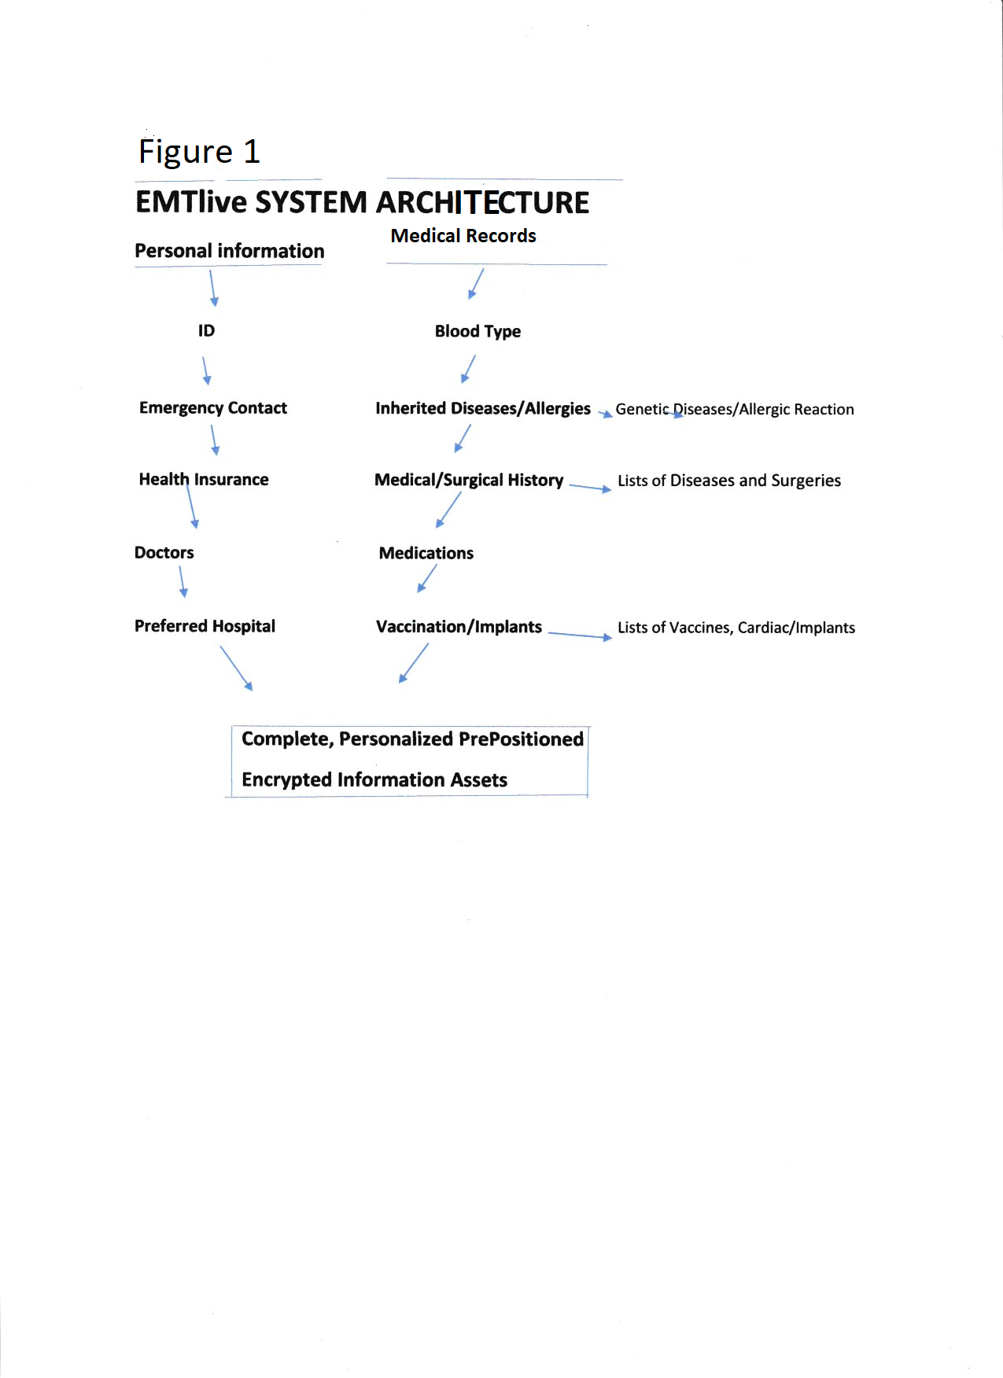

**Exhibit 1**

**Blood Type**

Information on Blood Types

**Exhibit 2**

**Health Insurance and ID**

|  |  |
| --- | --- |
| First Name | Last Name |
| Birthdate | Gender |
| Male | Female |
| Country of Citizenship | Social Security number |
| Primary Insurance Carrier | Policy Claim Number |
| Group number | Member ID |
| Plan code | Address |
| City | Street Number |

**Exhibit 3**

**Contacts**

|  |  |
| --- | --- |
| Primary Contact | Relationship |
| First Name | Last Name |
| Telephone Number | Cell Number |
| Address | State |
| City | Street & Number |
| Zip Code | Email |
| Secondary Contact | Relationship |
| First Name | Last Name |

Exhibit 4

Doctors

|  |  |
| --- | --- |
| Primary Doctor | Specialty |
| First Name | Last Name |
| Address | City |
| State & Zip Code | Street & Number |
| Office Phone | Cell Phone |
| Email | Hospital Affiliation |
| Secondary Doctor | Specialty |
| First Name | Last Name |

Exhibit 5

Inherited Diseases & Allergies

|  |  |
| --- | --- |
| List of Inherited/Genetic Diseases (CDC) | List of Allergies and Allergic Reactions (CDC) |
|  |  |
|  |  |
|  |  |
|  |  |
|  |  |

Exhibit 6

Medical and Surgical History

|  |  |
| --- | --- |
| List of Diseases (CDC) | List of Surgeries & Dates |
|  |  |
|  |  |
|  |  |
|  |  |
|  |  |
|  |  |
|  |  |

Exhibit 7

List of Medications and Dosages

|  |  |
| --- | --- |
| Medications/Strength | Times Per Day |
|  |  |
|  |  |
|  |  |
|  |  |
|  |  |
|  |  |

Exhibit 8

Vaccinations and Implants Information

|  |  |
| --- | --- |
| Vaccinations and Dates | Cardiac and other Implants and Dates |
|  |  |
|  |  |
|  |  |
|  |  |
|  |  |
|  |  |

Exhibit 9

Name of Preferred Hospital

|  |  |
| --- | --- |
| Name | Emergency Department Phone Number |
| Address | City |
| Street & Number | Patient Entry Location |
| State | Zip Code |